ASSIGNMENT NO-12

Problem Statement:- **Deploy and run project in aws without using port.**

Steps:-

1. **Sign in.** Sign in to your **GitHub and AWS account**.
2. Create an **EC2 instance** and give the commands in the advance details section.

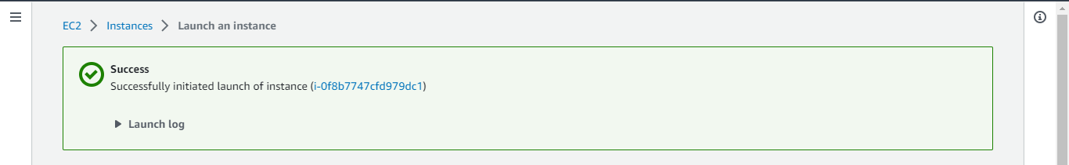

# Copy public IPv4 address(ex-65.2.126.120) and paste it on Bitvise SSH Client.Give username Ubuntu, initial method publickey, in client key manager import that same existed key pair .pem file(ex-key003.pem) and click Global1 in Client key and click log in.

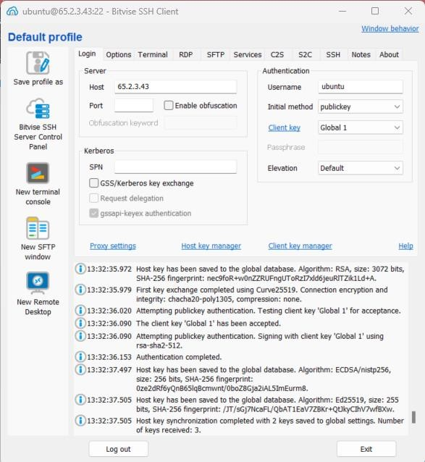

1. Click on new terminal console to open the terminal and write the following commands:-
   1. At first to check the directory type **pwd** after that type **cd/** to change the directory to root.

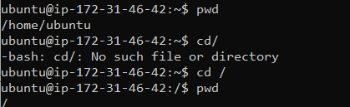

* 1. After that we change the directory to **etc/nginx/sites-available/**. After that type **sudo nano default** and change the location section.

C:\Users\ASUS\Desktop\aws\ass10\ass12(3).png

* 1. Commend the default location section and type this location portion:-

location / {

proxy_pass http://localhost:3000; proxy_http_version 1.1;

proxy_set_header Upgrade $http_upgrade; proxy_set_header Connection 'Upgrade'; proxy_set_header Host $host; proxy_cache_bypass $http_upgrade;

}

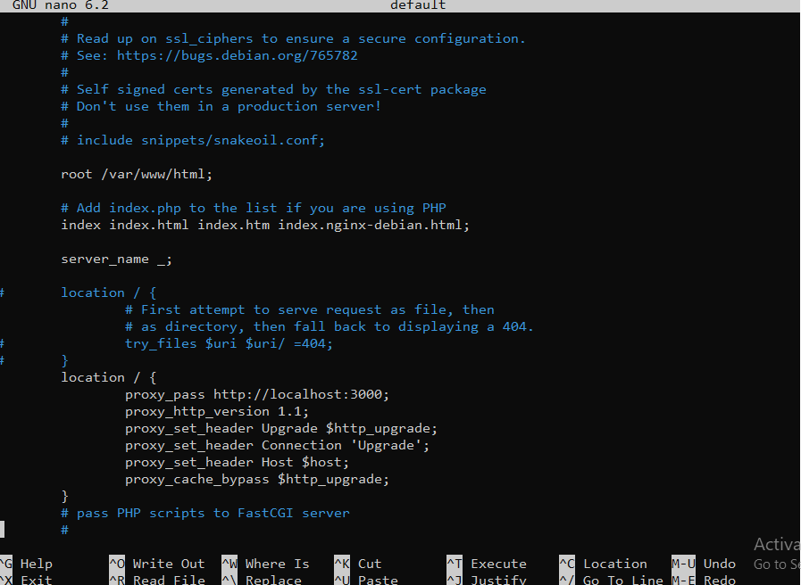After typing this save it.

# After that type sudo systemctl restart nginx to restart the server.

C:\Users\ASUS\Desktop\aws\ass10\ass12(5).png

1. Now copy the same IPv4 address and paste it in a new browser tab.

